The purpose of this document is to assist the student in selecting course requests for the following school year in their PowerSchool student portal account.

1. Login to NCEdCloud > Access PowerSchool Student – LEA 410 > 2. Click the pencil icon to the right of the course

Choose Class Registration subject. Courses associated with the subject

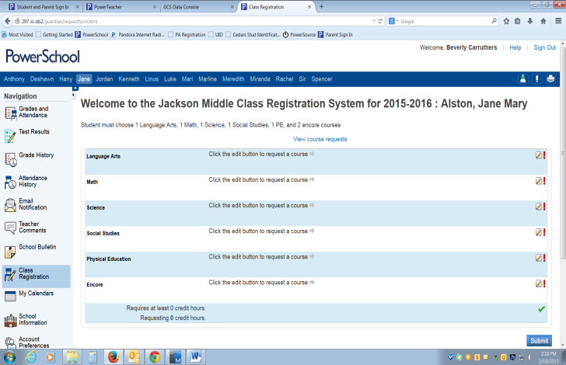The list of course subjects available will appear on the screen. will appear. Choose the course(s) required by clicking the box next to the course(s) name. Click OK.

Repeat the process for all subjects.

**Click on the pencil icon to see course options**

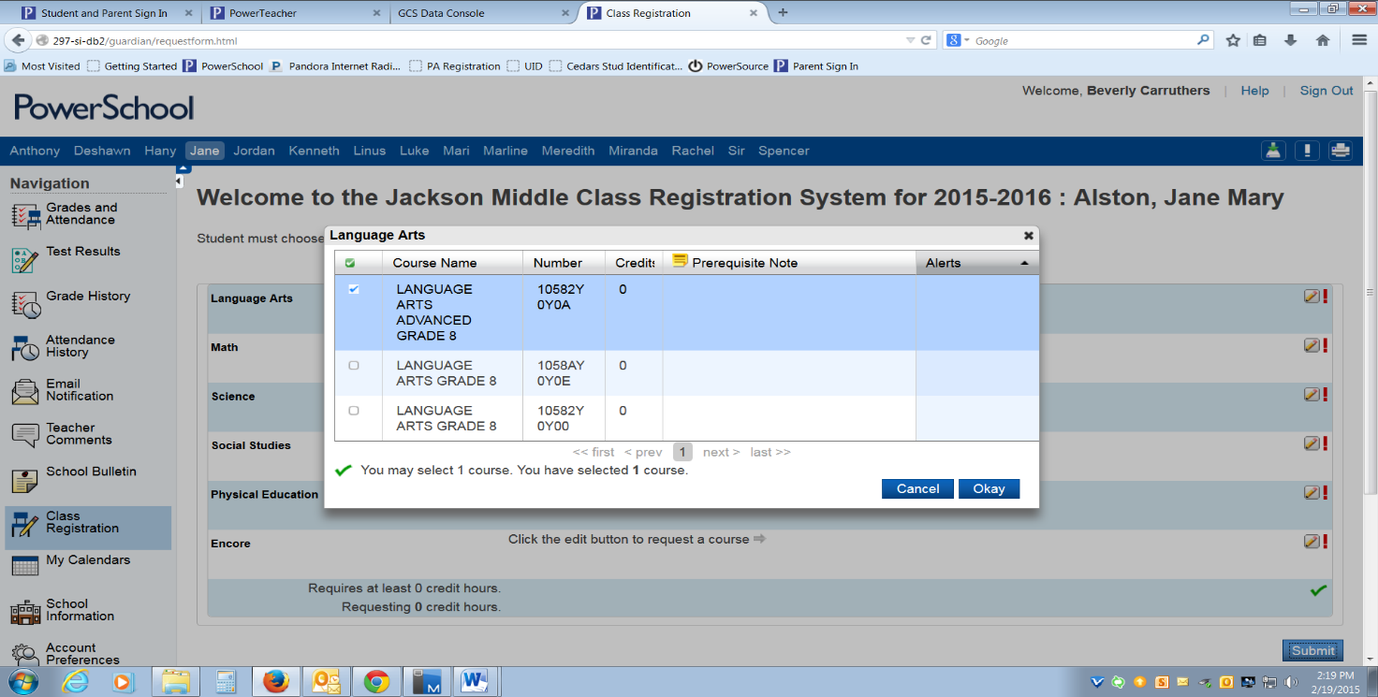

3. Once courses have been chosen for all subjects, click submit.

The list of your course requests will appear and the counselor at the school can now view the requests.

Online Registration Window for Students and Parents

Open From

February 14 – February 23

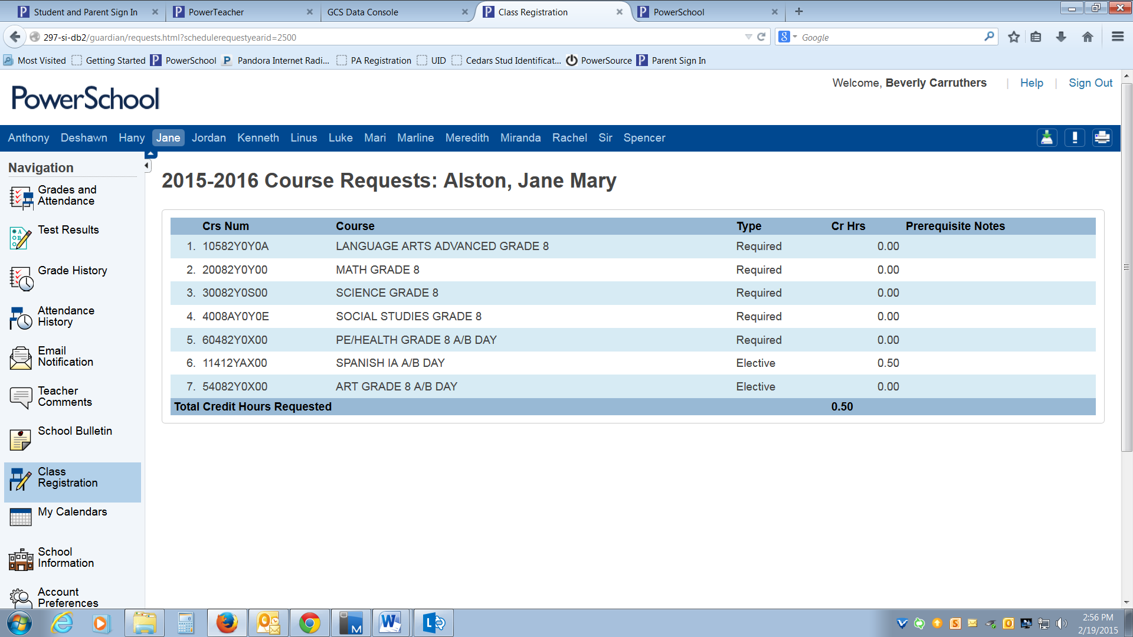

If ‘Submit’ is clicked before the number of courses required are chosen, an error message appears.

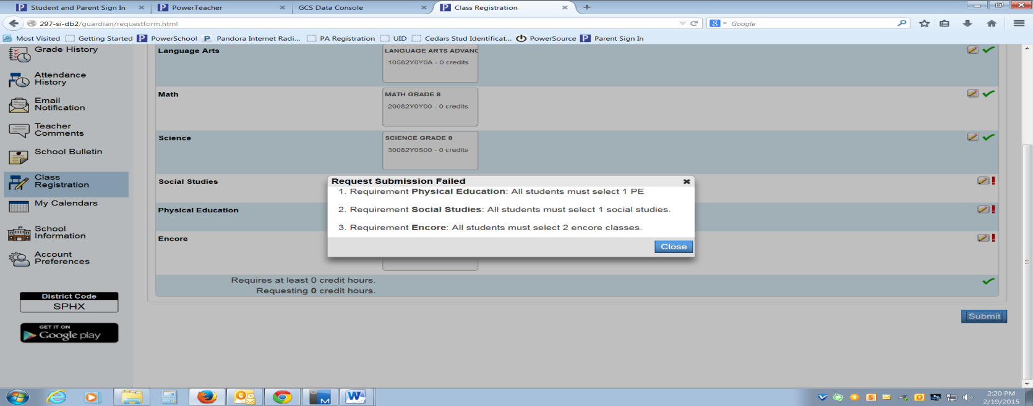

Close the error message and the system will return to the first screen. Follow the steps above until the appropriate amount of courses are chosen.